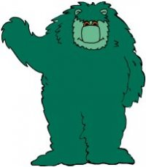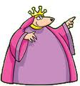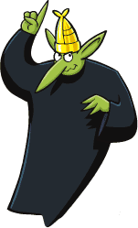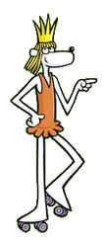

17

16

15

14

13

12

11

10

9

8

7

6

5

4

3

2

1

1. Muzzy is a monster.

2. Muzzy’s fur is blue.

3. The princess is called Sally.

4. The king is a lion.

5. The queen is skinny.

6. Corvax is clumsy.

7. The gardener is called Billy.

8. The gardener has got a motor bike.

9. Corwax hates the princess.

10. The princess loves the gardener.

11. Muzzy arrives in Gondoland in a spaceship.

12. The king is strong.

13. The princess is beautiful.

14. The princess has got a big school bag.

15. The royal family lives in a big castle.

16. Corvax has a very long nose.

17. The gardener and the princess run away.

**Tick (✓) the right answers:**